Sensitivity Analysis

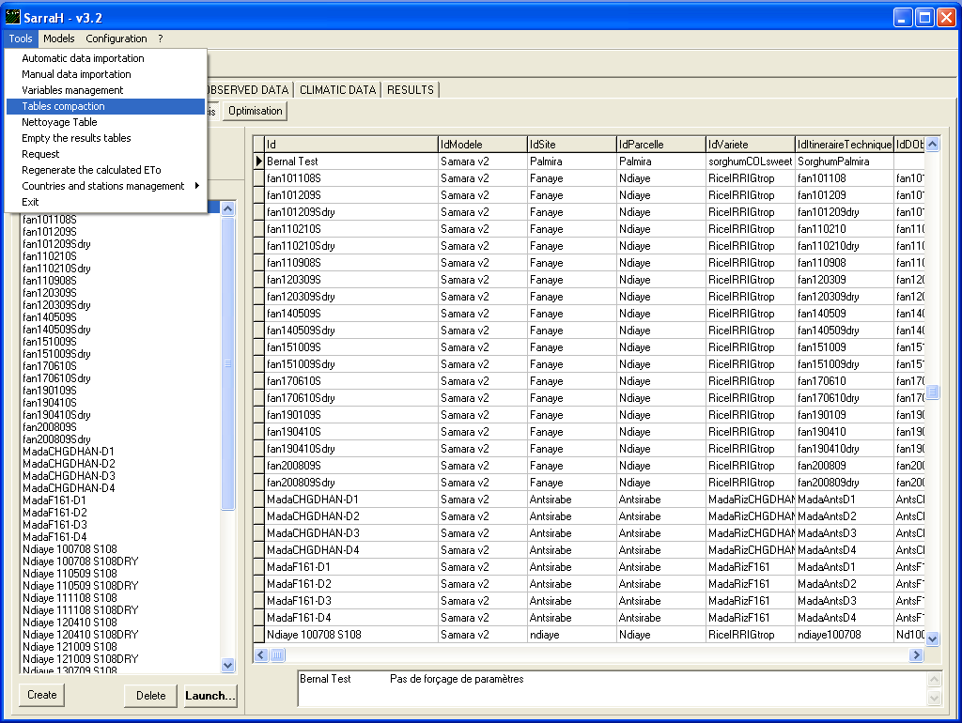
Before any execution of sensitivity analysis, because of the number of simulations created, we recommend saving the database. To make it, do a copy of DBEcosys directory and rename it with the date of the day at the end. We also advise to empty the results tables and tables compaction using the items in the tools menu of the Ecotrop platform.

Step 1
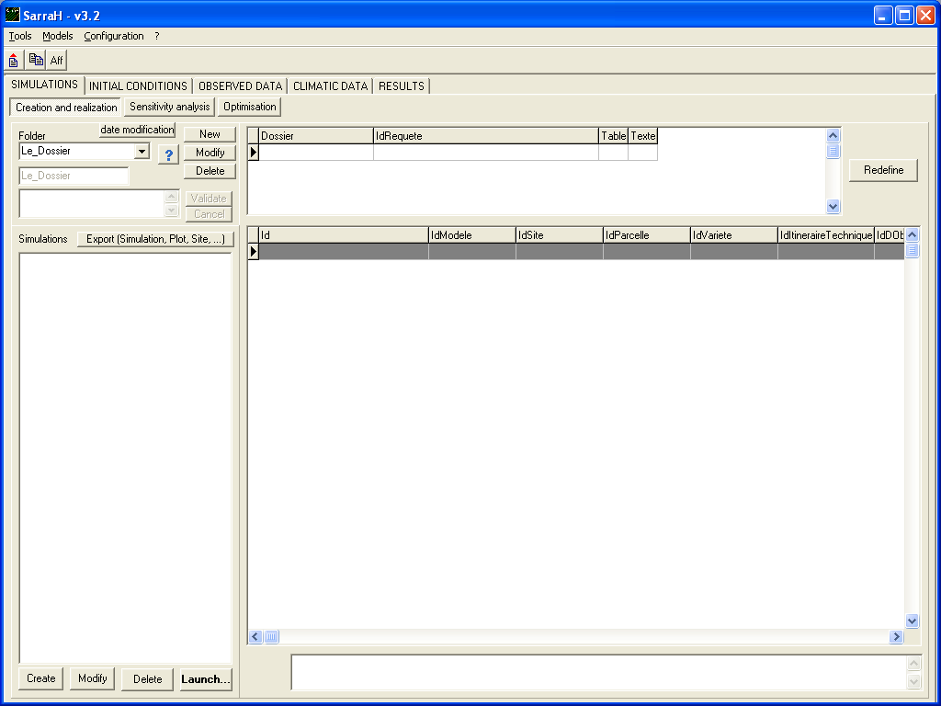
Select SIMULATIONS panel and Creation and realization tab, create a new folder.
In the folder list, select the new one created before.
At the right side of the window, click on Redefine.

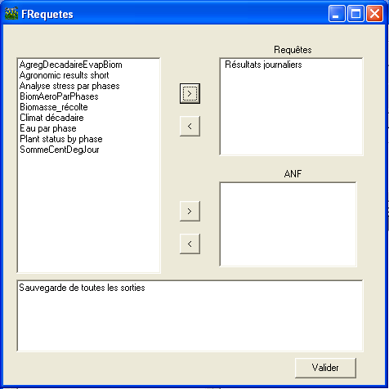
In the left side list, select ‘Résultats journaliers’ and click on . ‘Résultats journaliers’ will pass in the right side list. Now just click on Valider button.

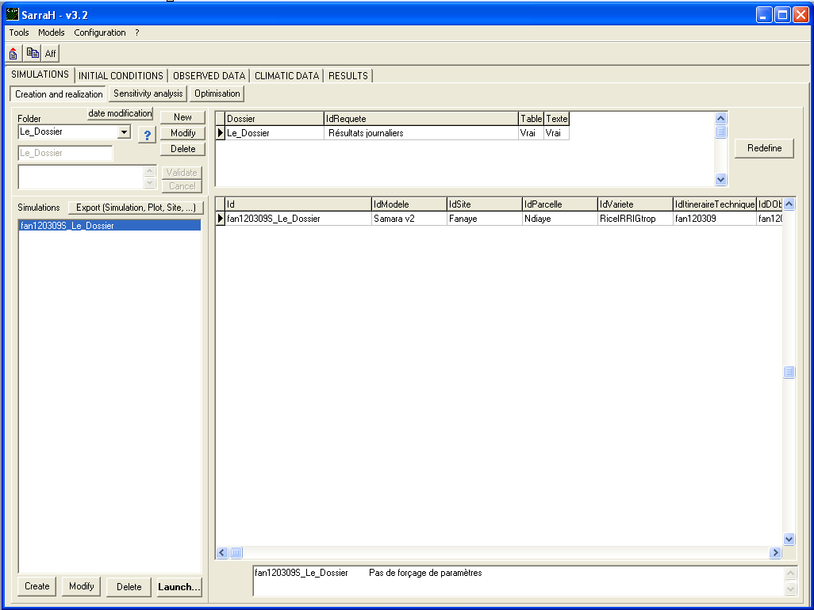
Now create a new simulation related to this folder. The sensitivity analysis will be based on this simulation.
Step 2
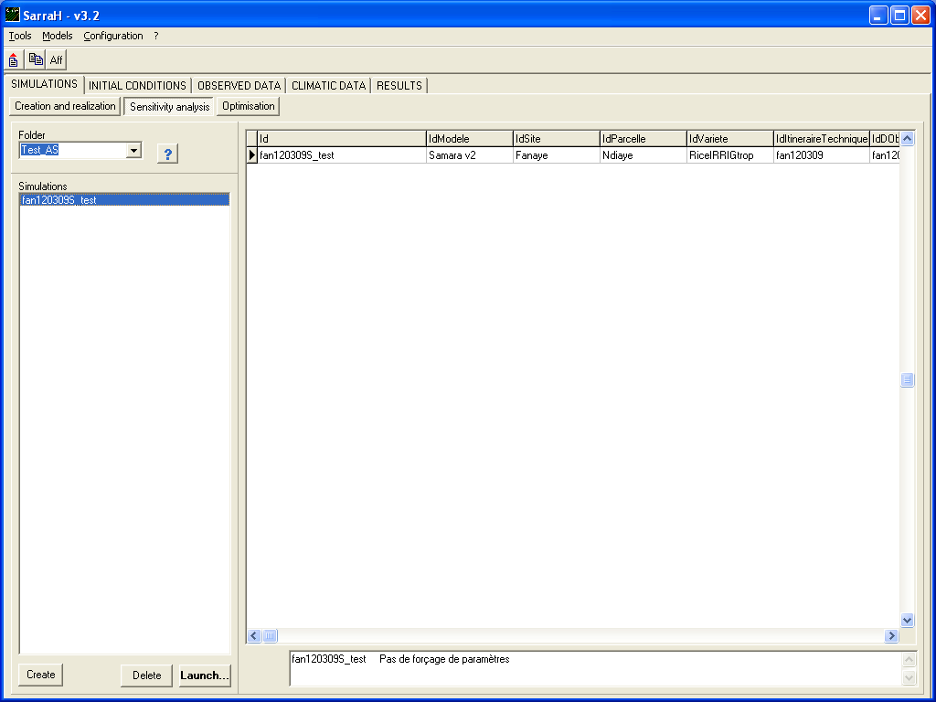
Select the simulation created for sensitivity analysis and click on Sensitivity analysis tab.
Click on Create button.

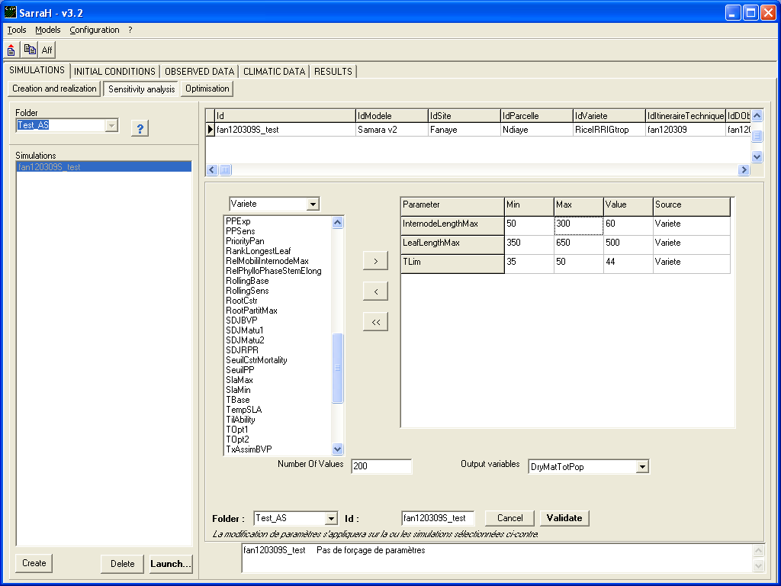
In the top list you can select the entity that defines simulations.
The list located just below will refresh with the parameters characterising the entity.
Select the parameter that you want to make vary and click on button.
The parameter will appear in the grid in the right side with his min-max range value, current value and the entity that it comes from. You can fix the min and max value of the variation range.
Below the parameters list and parameters grid, in the field Number of values you can choose the number of values to extract from the min - max range (i.e. if Number of values = 200, there will be 200 different values for each parameters. In this way, number of created simulations = Numbers of Parameters x Number of Values).
Select the output variable that will be choosing for the sensitivity analysis.
Click on Validate to launch the R script to generate experimental design and create automatically simulations that we need to execute the sensitivity analysis.

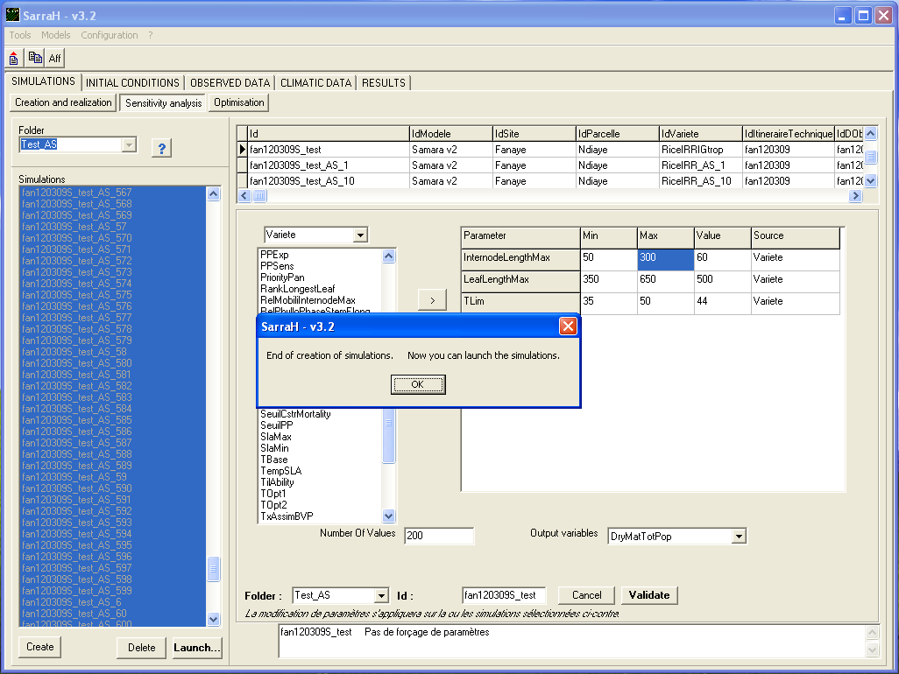
Please wait during the R Script execution and the automatic creation of simulations. It could take several minutes according to the number of parameters and number of values chosen.

Step 3
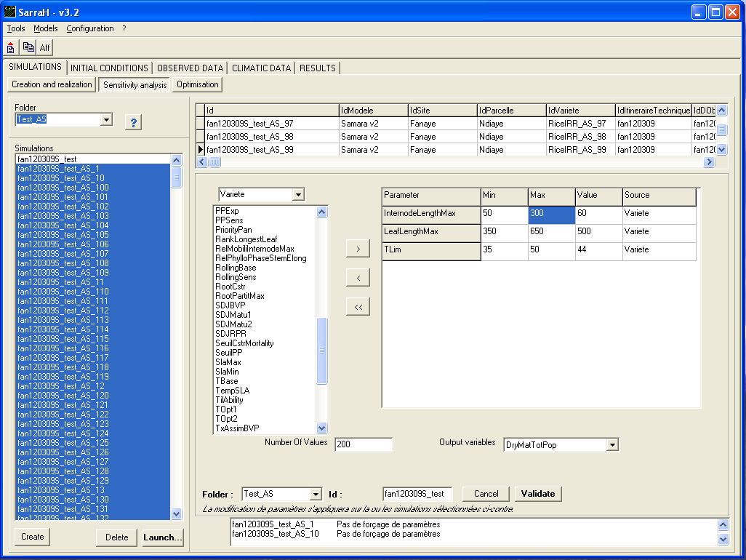
When creation of simulations ended, simulations list will refresh.
Now the simulations for sensitivity analysis appear in the simulations list and they are already selected.

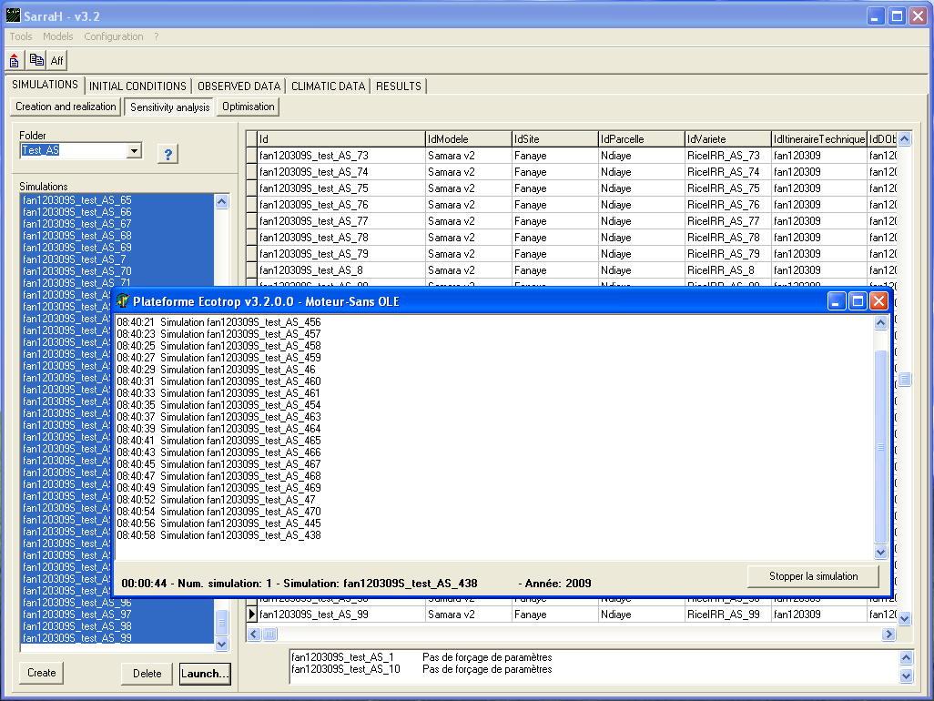
Click on Launch button just below the simulations list.
All the simulations will be calculated.
Wait until the motor calculation window close. It could take several hours according to the number of simulations to be calculated.
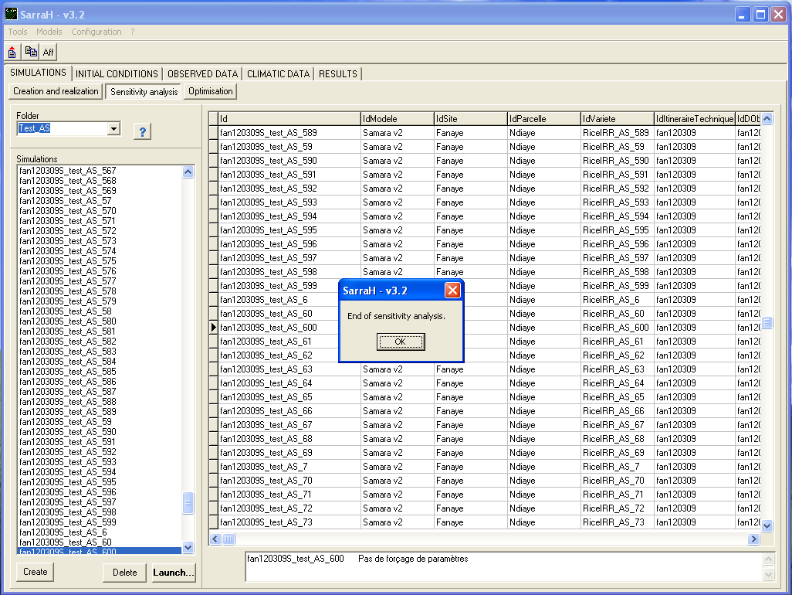
After motor calculation closing, an R script is executed. It could take several seconds to finish.

During the sensitivity analysis process, several text files are generated in the SarraH Interface directory (D:\Projets Cirad\SarraH\ by default):
- NameParamOut.txt contains the name of the output variable to monitor.
- NumberOfValue.txt contains the number of value to extract from each parameters range.
- ValueNameParam.txt contains the name, the min and max value and the entity from which it comes from.
- plan.txt contains the experimental design generated from the user’s choice.
- simulations_AS_list.txt contains the id of all the simulations created for the sensitivity analysis.
- plan_result.txt contains for each line of the experimental design and the value of the parameters and the respective value of the output variable monitored.
- res_as.txt contains the final result of the sensitivity analysis.

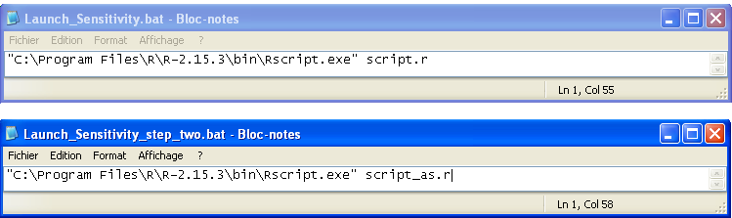
The sensitivity analysis use R software. It recommended installing it in the default path proposed during the install.
Indeed, batch files are called to launch R script, the files contains the default path for R (C:\Program Files\R\R-2.15.3).
If you have installed R in another directory, you have to change the path with the right one in the two files. To do it, right click on the batch file and modify or edit, the file will open. Change the path, save and close the file.

